How to create a new system name in pega

First we can find the existing system settings given by pega

Go to sysadmin > system

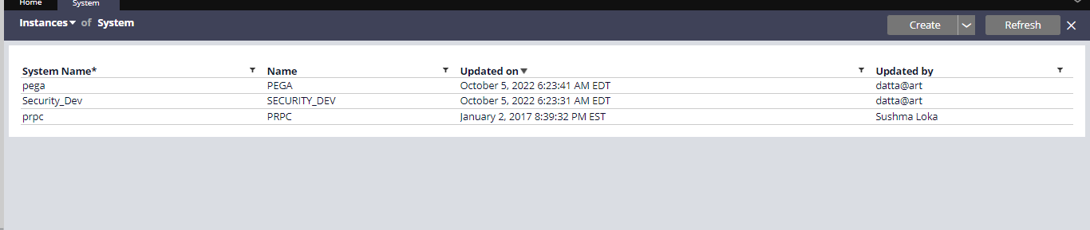

Usually you would find the pega and prpc security_dev is created by me

Usually the current name would be pega

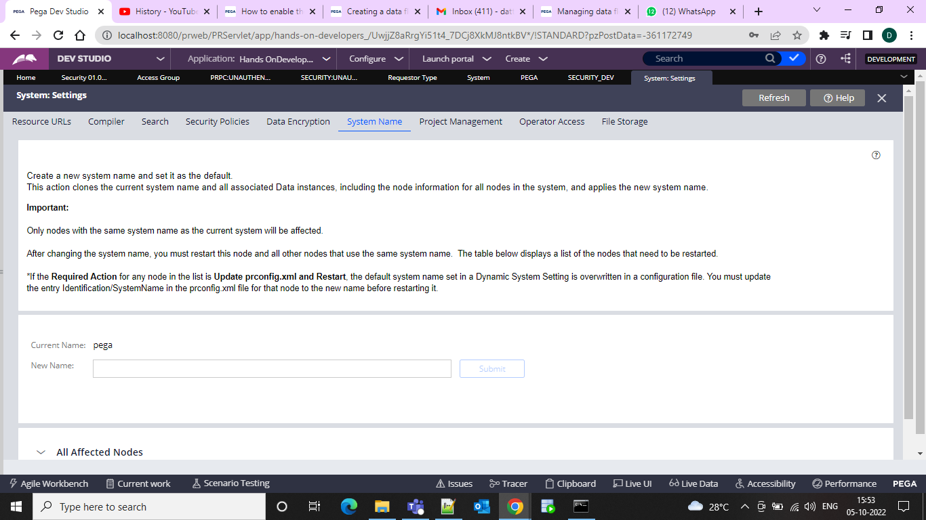

And after that we can manually update by giving the system name and update but that is not the preferred approach

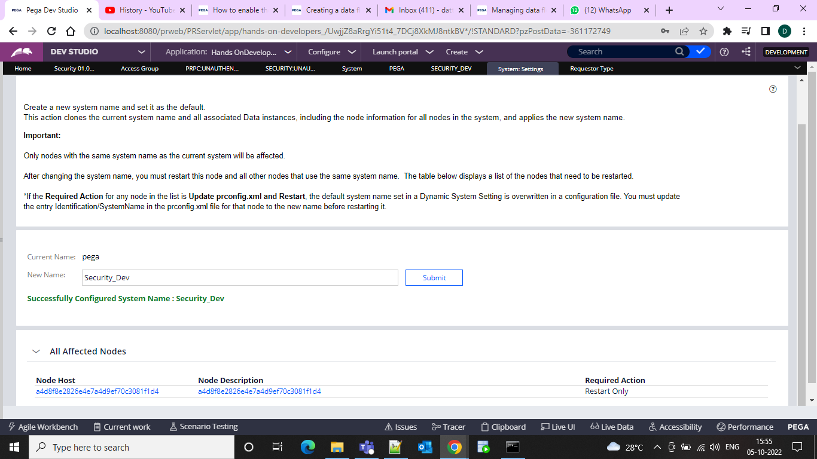

And to creatre one you can reuse it and in the dialogur box can configure under which server and I configured as DEV server

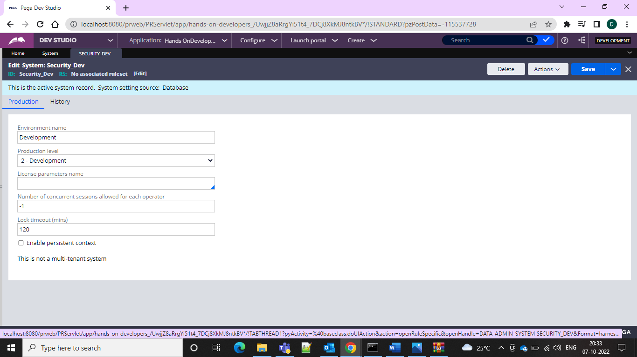

And inside this we can configure and save and the usual provided timeout is the 120 seconds can change it and after doing it can open configure > system > system settings and can do the change to the system and do a server restart and in the requestor type also these get created in the back end

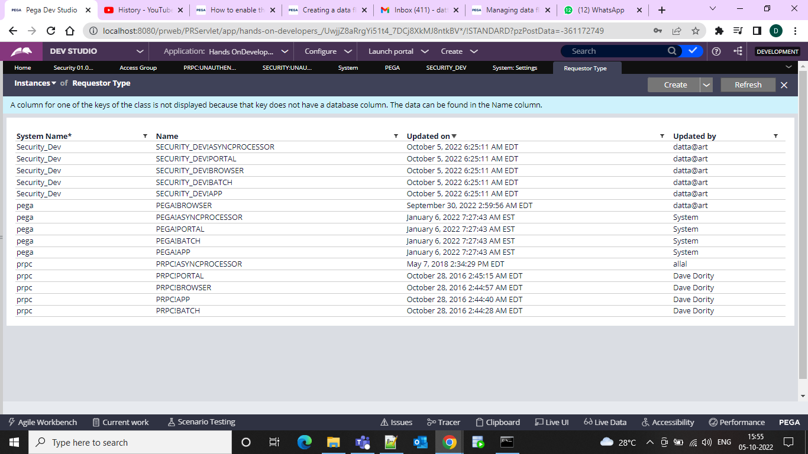

And also in the dynamic system settings also get updated

We can check for pr config and in that we can find our new Value

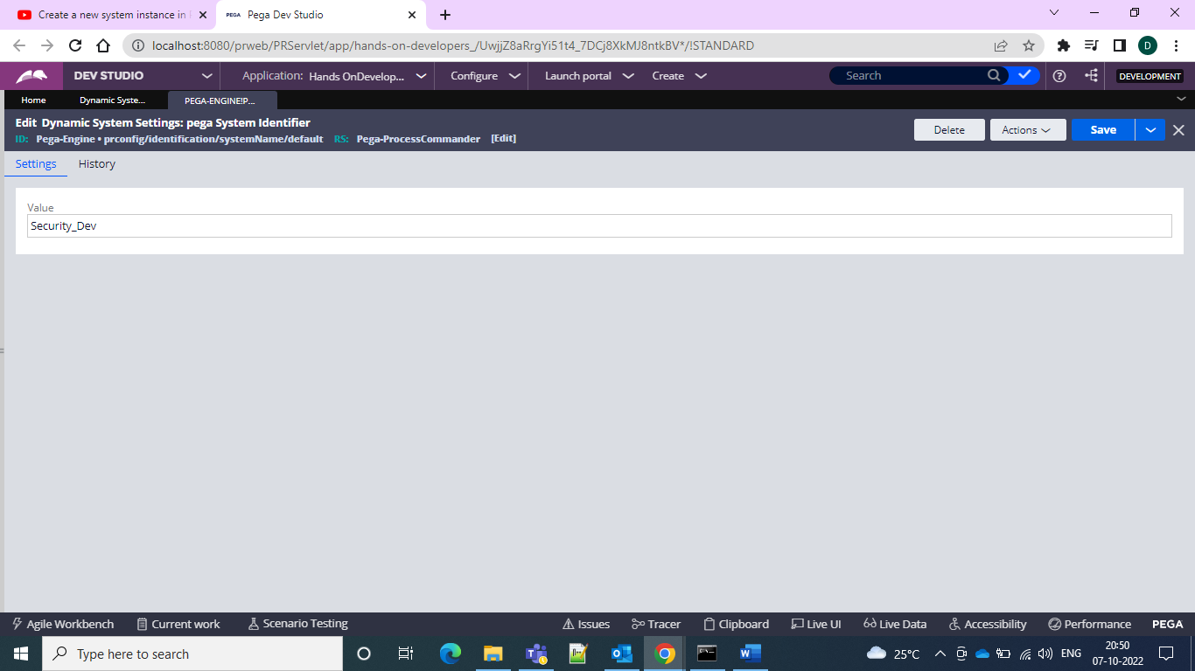

And the system settings are updated